Wondrous Ancient Worlds

AR Experience Planning Sheet
Wondrous Ancient Worlds  AR Experience Planning Sheet | 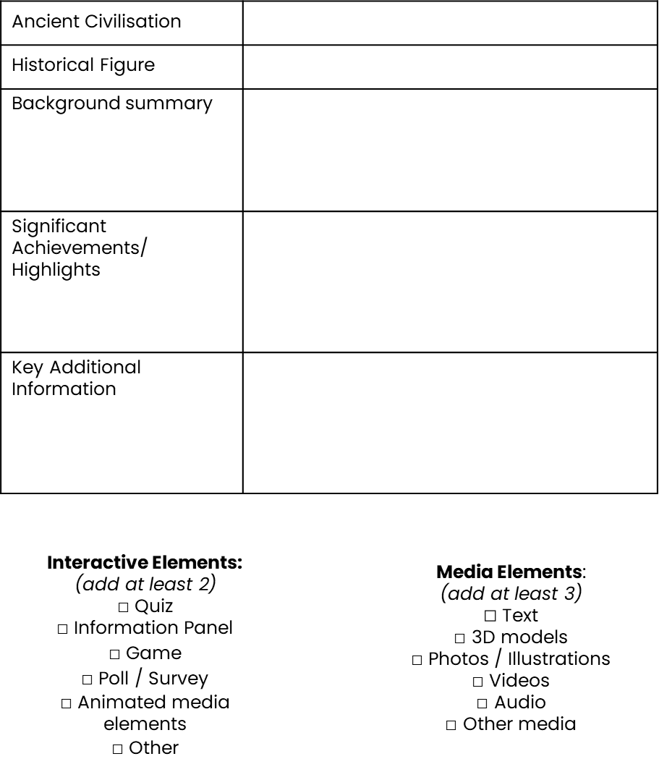
Student Name:

Instructions: Complete these planning sheets for your Augmented Reality creation.

Ancient civilisation
Historical figure
Background summary
Significant achievements / highlights
Key additional information

Interactive elements: (add at least 2)  - Quiz  - Information Panel  - Game  - Poll / Survey  - Animated media elements  - Other | Media elements: (add at least 3)  - Text  - 3D models  - Photos / Illustrations  - Videos  - Audio  - Other media

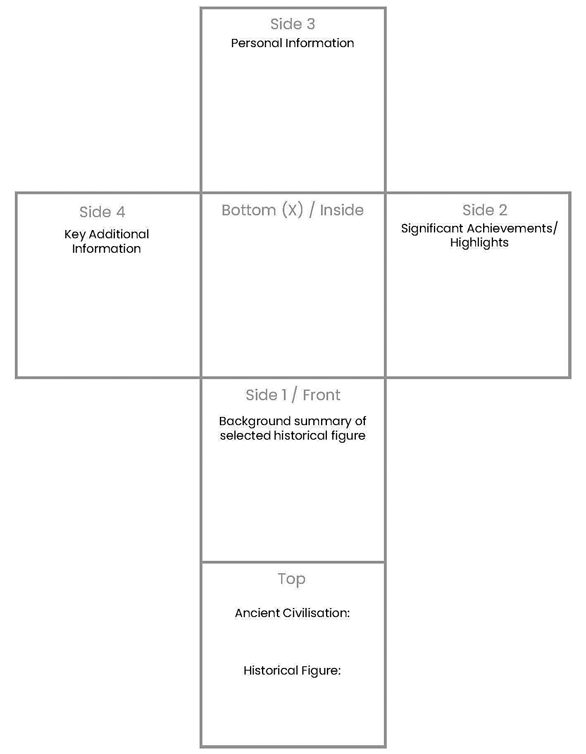
Use this 3D net to plan your Merge Cube or physical cube creation of your chosen historical figure (print this page).
Personal Information
Key Additional Information
Significant Achievements/ Highlights
Background summary of selected historical figure
Ancient Civilisation:

Historical Figure:

