VR & AR LESSON PLAN

Forces in Action
AR Station

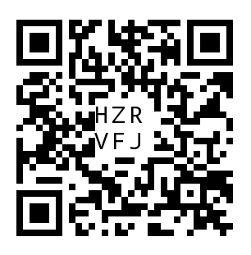  Fun With Physics |   Physics With CoBlocks

What types of forces did you see in action?

______________________________________________________________________________
______________________________________________________________________________
______________________________________________________________________________
______________________________________________________________________________
______________________________________________________________________________

What were examples of balanced and unbalanced forces?

______________________________________________________________________________
______________________________________________________________________________
______________________________________________________________________________
______________________________________________________________________________
______________________________________________________________________________
HHVR Station
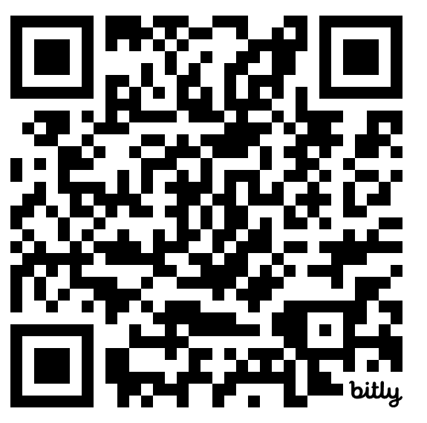
PlankWorld 360
What are the forces at work in this video? (gravity, friction)

______________________________________________________________________________
______________________________________________________________________________
______________________________________________________________________________
______________________________________________________________________________

What examples of balanced forces did you see? What examples of unbalanced forces?

______________________________________________________________________________
______________________________________________________________________________
______________________________________________________________________________
______________________________________________________________________________

What makes a force balanced or unbalanced?
______________________________________________________________________________
______________________________________________________________________________
______________________________________________________________________________
______________________________________________________________________________

